The main purpose of this group Visual Analytic task is to find:

  - How was each of the four strategies (mentioned in the "background") effective? Did each of them achieve controlling the spread?

Visualization 1: hygienic processes (washing hands, wearing masks, etc)

Visualization 2 encouraging testing
When a communicable disease outbreak begins, the ideal response is for public health officials to begin testing for it early.
Testing helps to stop the spread of Covid by taking measures like isolation and contact tracing.

Potential timeline:

$450 payment available for isolating waiting result

$1,500 payment available for quarantine for 14 days
Encourage testing for asymptomatic people?
Initially, the only test available required getting a sample from the back of a person’s throat. Simple testing techniques have been developed, also shorten the waiting period. (Early in the pandemic, there was not enough capacity and limited supplies to collect and process the tests, which resulted in delays. However, lab equipment has improved, capacity and supply have expanded, and results are being returned, on average, within 3-4 days. In fact, point-of-care tests will be available that provide a result in less than 15 minutes!)

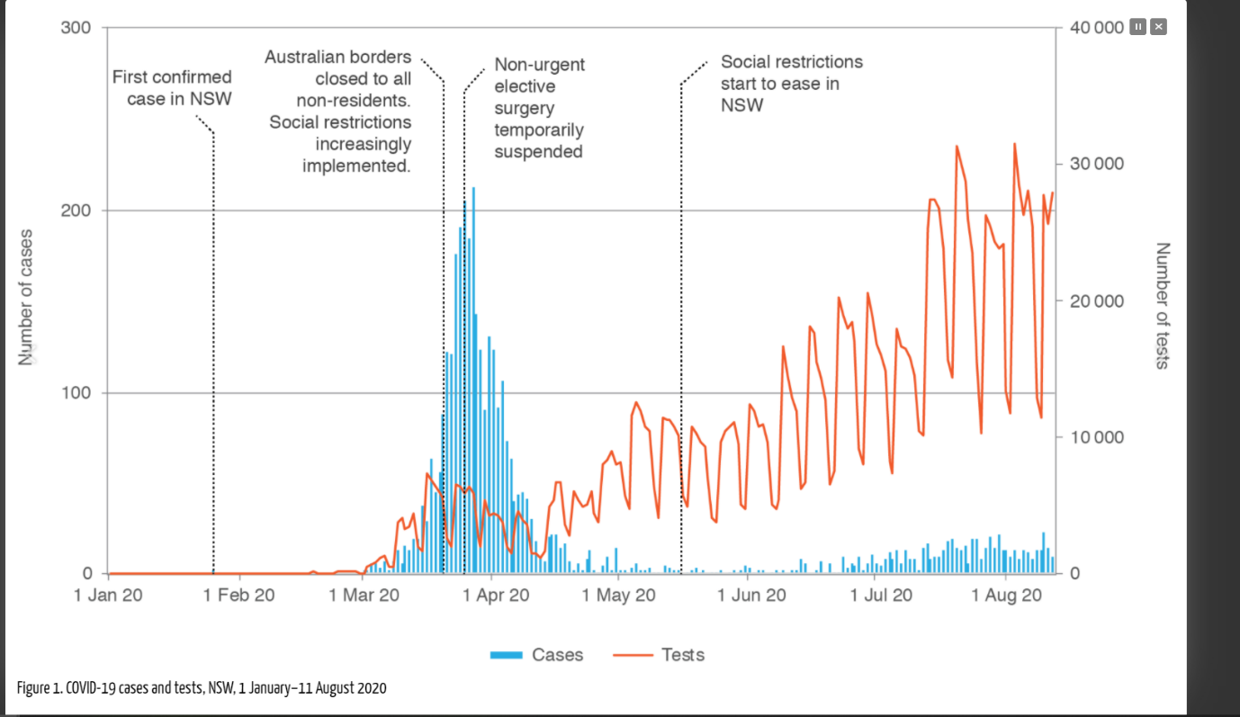

Visualization 3 controlling the flow of people through various travel restrictions (both international border and interstate border control)
- The number of overseas acquired covid cases decreases after border restriction?
- The number of interstates acquired covid cases decreases after border restriction
- The number of interstates acquired covid cases decreases after border restriction
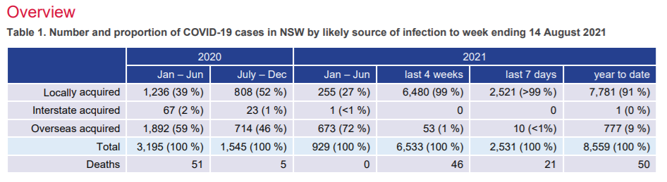
E.g., International boarder closure
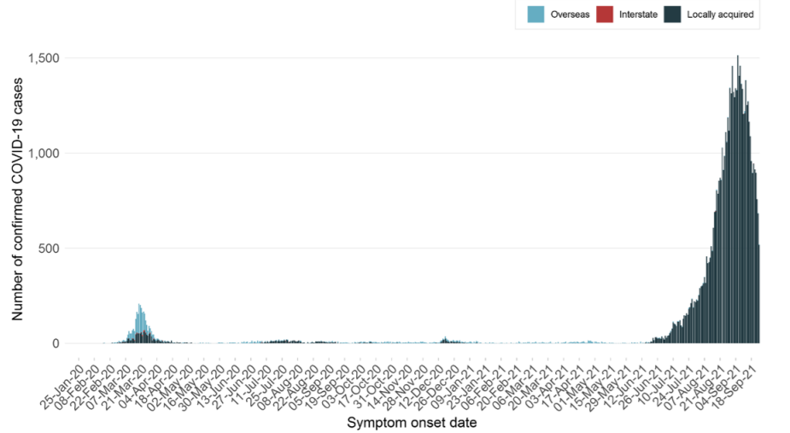
Data: locally acquired cases, interstate acquired cases and overseas acquired cases
From 29 March 2020 returned travellers have been quarantined in hotels for a 14-day period and travellers who develop symptoms are isolated until no longer infectious. Returned travellers are screened on entry and exit from quarantine and following release from quarantine. • From 22 January 2021 (local time at departure point) all people travelling to Australia on flights must provide proof of a negative COVID-19 PCR test result at the time of check-in.

Visualization 4 encouraging vaccination.
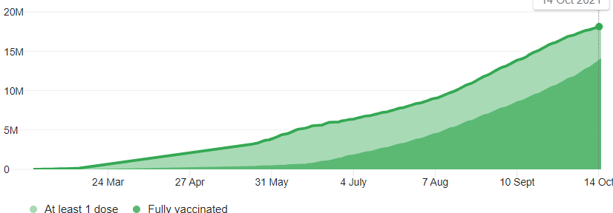
COVID-19 vaccinations began in Australia on 22 February 2021.
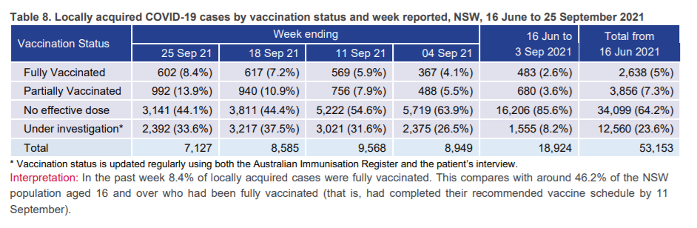
Data: cases that are fully vaccinated, partially vaccinated and no dose
Stacked bar charts:

Partially vaccinated vaccinated
Fully vaccinated

- There have been a number of waves of COVID-19 spread in the past and many of them seem to be controlled (came down in the number of new cases). Was there one particular strategy that worked better than others? or Was there a particular combination of strategies that worked the best?
Wave 1: Combination of the first three strategies work the best
Wave 4: vaccination works the best, because Delta variant is more infectious, the other three measures could not control its spread anymore.

- Each strategy was introduced hoping that it will have a significant impact in controlling the spread. However, it seems that the COVID-19 managed to re-spread. Was there any evidence that might indicate that any particular strategy did not work as anticipated?

- Why does boarder restriction not work?
Almost all cases reported in the last two weeks in NSW were locally acquired (15,712/15,740 cases, or 99.8%). Of the 7,127 locally acquired cases reported in the week ending 25 September 2021
Data: locally acquired cases

- Why does hygienic processes not work?
Delta variant is highly contagious, about twice as contagious as previous variants

https://www.health.nsw.gov.au/Infectious/covid-19/Pages/weekly-reports.aspx

  - Data
  - 10/19 Data pre-processing
  - Geo map

Tableau tutorial
10/19 7pm meeting

